 | 

 |  |  |  |  | 

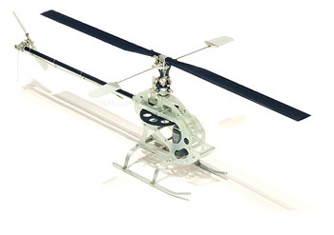 | 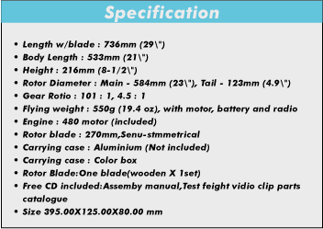
CyberCopter (CY06) is an electric helicopter that is made by Hong Kong Aero Model Design Ltd. This is the smallest aluminum alloy made 3Delectric helicopter in the world and having a fairly same size with the FEDA and thunderbird. It is a perfect indoor 3D flying electric helicopter with the ultimate performance., beginner could learn more in deep about the actual mechanism of flying helicopter. Obviously, the simple assembly work allows flyer to concentrate on flying and enjoying fun while their counterparts suffer from setting up those complicated gas fueled helicopter. CyberCopter can even earn more advantages from its sensitivity motion and it can fly indoors simply and safely.
The different between CyberCopter and FEDA or thunderbird are the airfoil blades of the CyberCopter can be rotated variably, it is not only able to fly in three dimensional way and flying reversibly, but also able to make a lot of shifting and moving due to its CCPM structural conditions. Beside, the tail rotor of CyberCopter is different compare with the FEDA and thunderbird. Both of them are rotating by using a single independent motor. However the CyberCopter!|s tail blade obtains the torque through the transmission shaft from the main motor gear. The rudder is controlled by the servo which adjusts the angle of the tail blade. Meanwhile, a gyro is installed and integrated with the rudder servo in order to balance the throttle torque and stability of the rudder motion.
The accessories and parts of the CyberCopter are fairly the same as other gasoline-fueled helicopter. More or less, CyberCopter is classified as Advanced Tactical Fighter (ATF) kit. It only comes with the necessary parts and several tiny components. After getting the CyberCopter, player should decide their own radio controller, gyro, 4 pieces of micro servos, electronics speed controller as well as battery and charger. After installing those electronics devices such as servos, gyro, receiver and ESC on to the main body, the final assembly is as simple as fasten the tail ready part into the main body. Nevertheless, we would recommend that beginner should get assist from experienced heli-flyer during the assembly process. With no doubt, beginner could learn more about the actual mechanism of flying helicopter. Obviously, the simple assembly work allows flyer to concentrate on flying and enjoying fun while their counterparts suffer from setting up those complicated gas fueled helicopter. CyberCopter can even earn more advantages from its sensitivity motion and it can fly indoors simply and safely.
CyberCopter's special features CyberCopter is featured a sophisticated CCPM structure and it allows the variation of propeller offset from negative to positive. In other words, CyberCopter can perform a 3D motion. In both theory and practice, it can even fly upside down like those gas fueled helicopter. Therefore, CyberCopter is a total solution for both beginner and experienced heli-flyer who want to enjoy fun with no hassle. The small size also break limit of space while we are living in the city. CyberCopter can even fly inside a house, office and garden etc. CyberCopter is powered by electric power motor with an 11.4V Lithium battery. It will not generate as much noise as those gas engine choppers and minimize the effect of sound pollution.
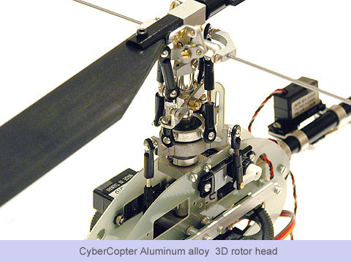
The size of CyberCopter is outrageously tiny and assembly precisely. The above picture shows the super tiny electric helicopter with an alloy 3D rotor head. For this incredible perfectly made helicopter, nobody can resist having fun on flying it!
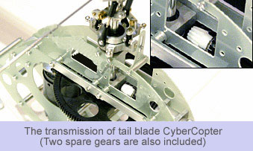
The torque transmission from main gear to tail blade is achieved by Two 45 degrees gear set. It allows transmission of motion to shift motion axle to 90 degree.
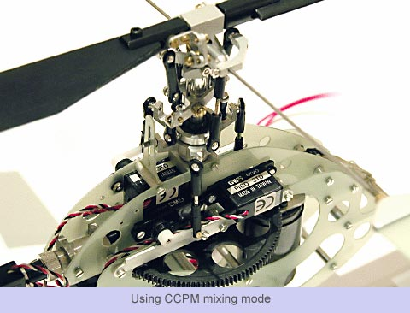
The CyberCopter is employing CCPM mixing mode as its motion control system. The word of CCPM stands for Cyclic/Collective Pitch Mixing and it offers the user a control system that accomplish the same control inputs as the one servo standard system, but with increased precision and reduced complexity.
CCPM system utilizes three servos for the three main controls: Aileron, elevator, and collective. The three servos are powered independently, but they work to each other in order to achieve a specific motion. If in case, an aileron input is given, all three servos cooperate to adjust the swash plate fore and aft. For collective, the servos will force the swash plate up and down the main rotor shaft. With two or three servos working at the same time during any given control input, servo torque is maximized and servo centering is also increased. In addition to these benefits, CCPM achieves these control response only require lesser control rods and parts to setup.
The importants of Assembling There are couples of experience to share with, in order to make the assembling process better off. Be aware! Never put on the main rotor blade before neither completing the assembling nor the flying rehearsal.
1. Precaution of installing tail boom. It has to be close enough but not too tight or it will make a great rotating resistant. However, it cannot be loosened or the gear will easily drift or even wear out.
2. Screw should be tightening. All the screw and nail should be carefully checked before the flight, especially the one that will be mounted on the main blade, the body as well as the rest of the components and accessories.
3. Tuning and balancing the rotor blade. Keep helicopter horizontally, and balance the length of the both sides of blade before the blade is tightened firmly.
4. Assembling of gyro. The reserved space of gyro is very precise. Cycbercopter has limitation on the servo size.Only servo with size less than 22.8mm x 9.5mm will fit it. The gyro of Himark MC-50BB 9g cannot be installed since it is oversize. The PICO servo of GWS is highly recommended as it can be perfectly fitted in. Plus, the price is more economical and the performance is outstanding.
5. Tail blade modification. It is controlled by the tail pitch which is placed in a tiny crust. Since the original screw in package is pretty much smaller, it is still required to take a risk of getting out during the flight as a matter of fact. In spite of everything, the problem can be easily resolved by putting a widened metal bearing underneath the screw head
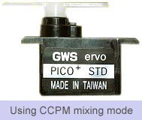
6. The connection order of gyro and receiver. The gyro connection of the "CCPM" mixing mode is different from the one of "machine control" mode. If you have got a CyberCopter, and would like to know more about it please read the user manual page 12. The diagram in that page cardefully shows the connection of gyro and the receiver; the left pitch to the sixth path, the right aileron to the first path; the front elevator gyro to the second path, then adjusting the type of mode to "CCPM" on the XX. Never connect the XX during the adjustment in order to get rid of the chance that inappropriate rotating spot is harming the gyro. For more detail of the "CCPM" mixing mode remote radio controller, please refer to page 11 of the user manual.
7. Alternative connection. The third path of the receiver is connected to the speed controller. The speed controller is variable, 20A or above speed controller. The following item are highly recommended. A high current ESC such as Jeti or Feigo Electronics Speed Controller is suitable for the throttle control. So the receiver is not necessary to connect the battery individually. By the time of the battery is connected to the speed controller, the conduct wire of the speed controller and the receiver is able to provide power to receiver. So the receiver should not be connected to the battery separately. Before the flying rehearsal, checking the rotating direction of the motor as well as connecting the power out of the wire of the speed controller to the motor is necessary. The forth path should be connected to the XXX and the line out of it connects to the gyro. It is advised to employ GWSXPG03 for the role of gyro. Certainly, it is better if FUTABA GY240, 401 or any better gyro could be used.
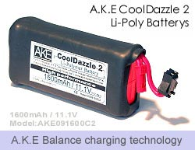

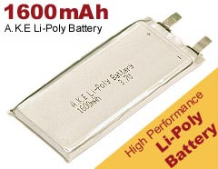 | 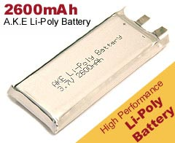
8. About the battery, according to the suggestion of the user manual, for this tiny helicopter, it only can be fitted in by AAA (7) type 9.6V NiHm, the capacity is between 600-1000mAh. However we recommend the user to use A.K.E Three Cells Lithium such as? 1300 cool or Lithium battery which have a higher capacity. The demonstration tells that this kind of battery is better than the ordinary NiHm. Since its capacity is higher as well as the density, it is the curial power supply which is perfectly fitted in the CyberCopter.
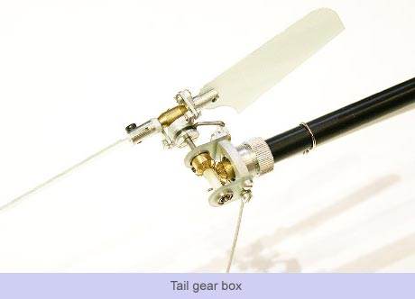

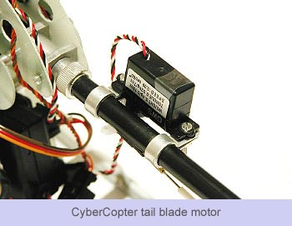

Even though the CyberCopter has such variable features and literally good performance, we have to remind you that there still are certain difficulties assembling and tuning this kind of CPM helicopter. Thus, it is better to manipulate it along with expertise.

